**Linux Administration Essentials ASS-2**

**Assignment Day 5**

1. **Add a 10GB disk to the CentOS.**

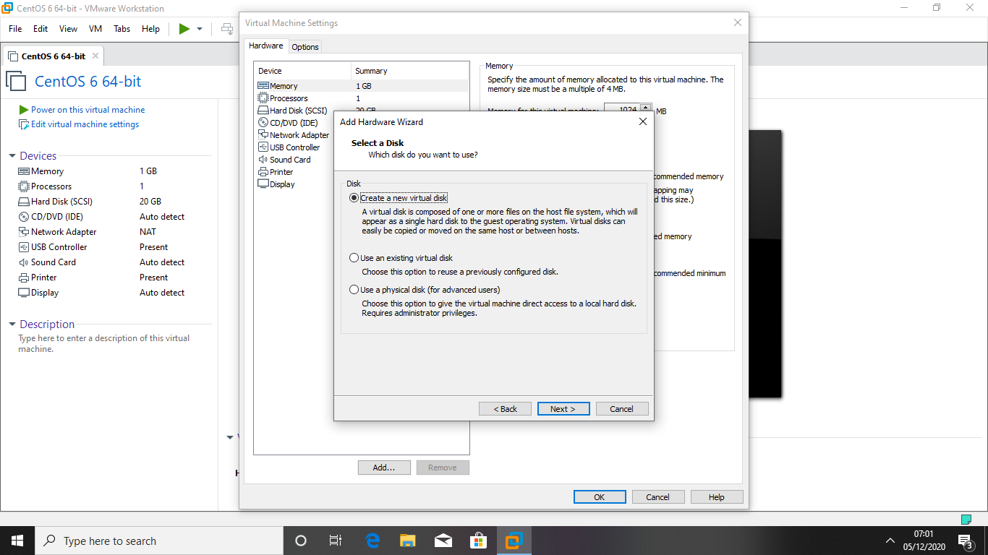

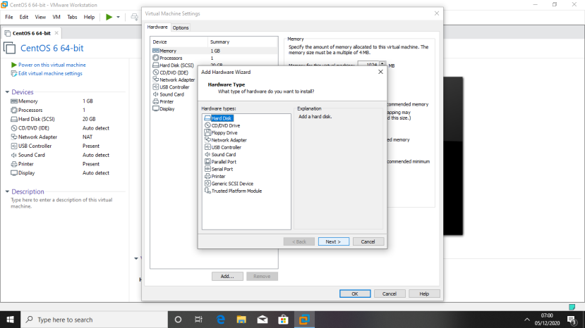

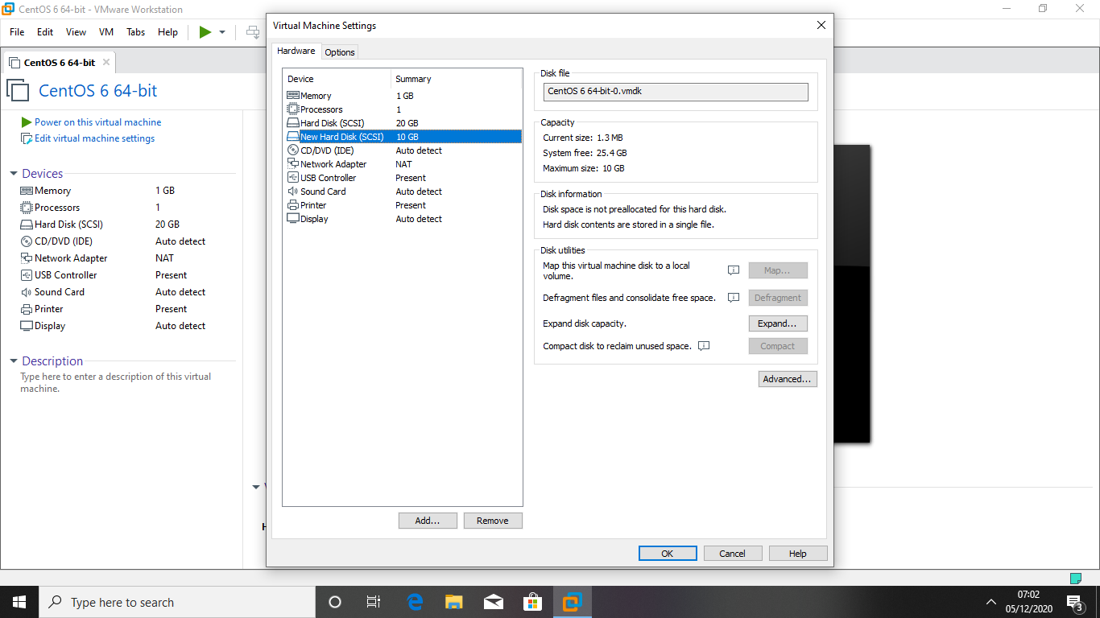

1. **Create 2 Partitions 4GB and 6GB of Space respectively**

**.**

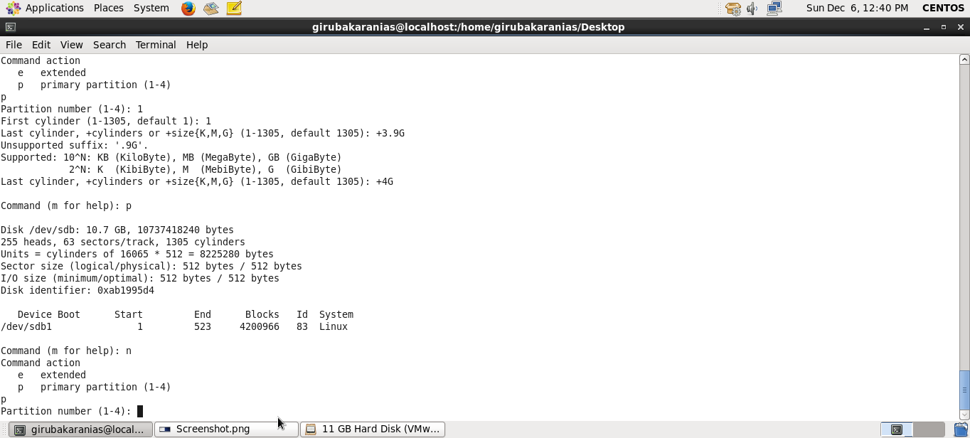

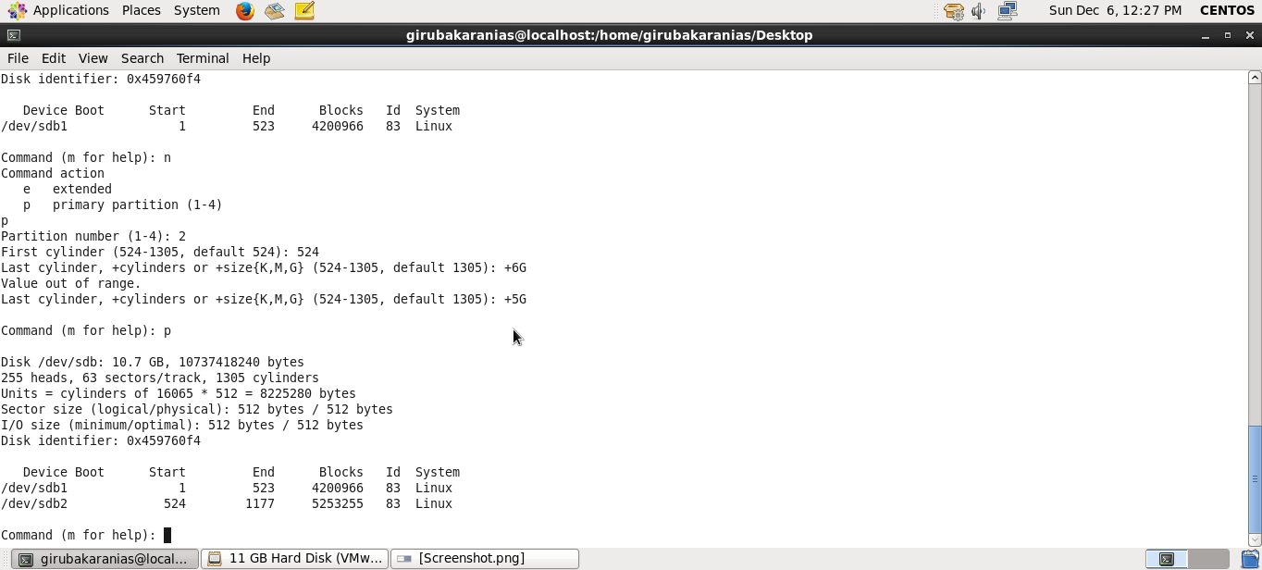

1. **Format 4GB with xfs and 6GB with ext4 file system**

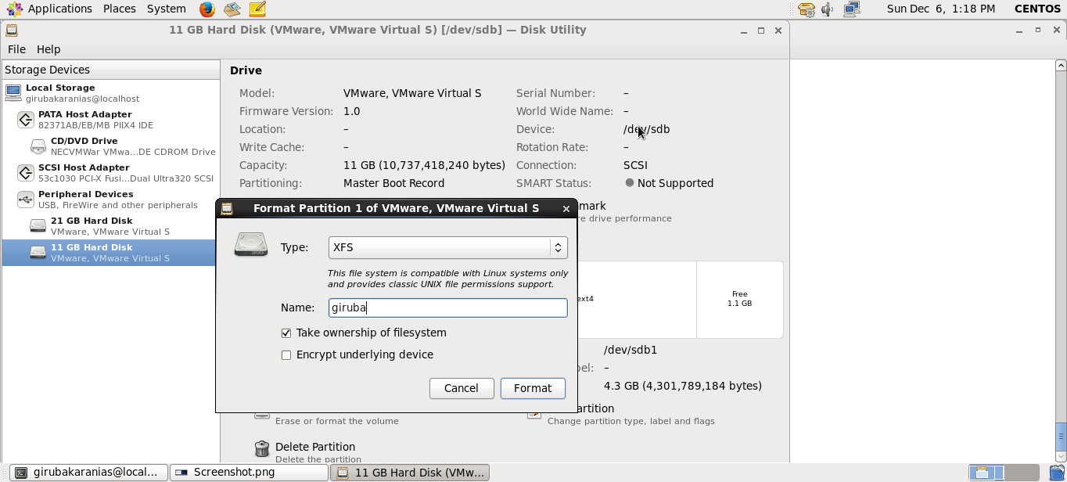

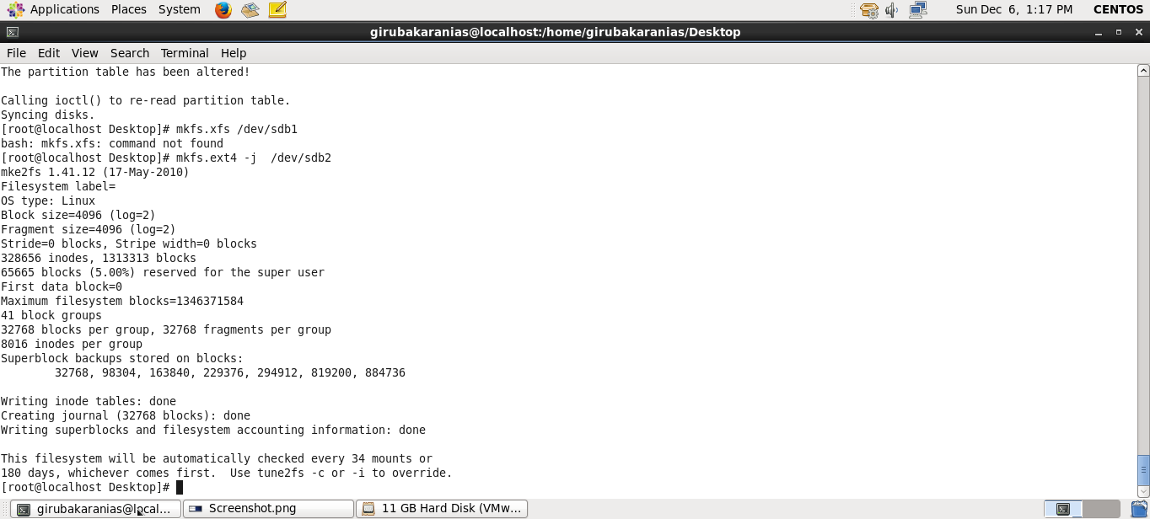

1. **Mount 4GB and 6GB in /data and /music directory respectively.**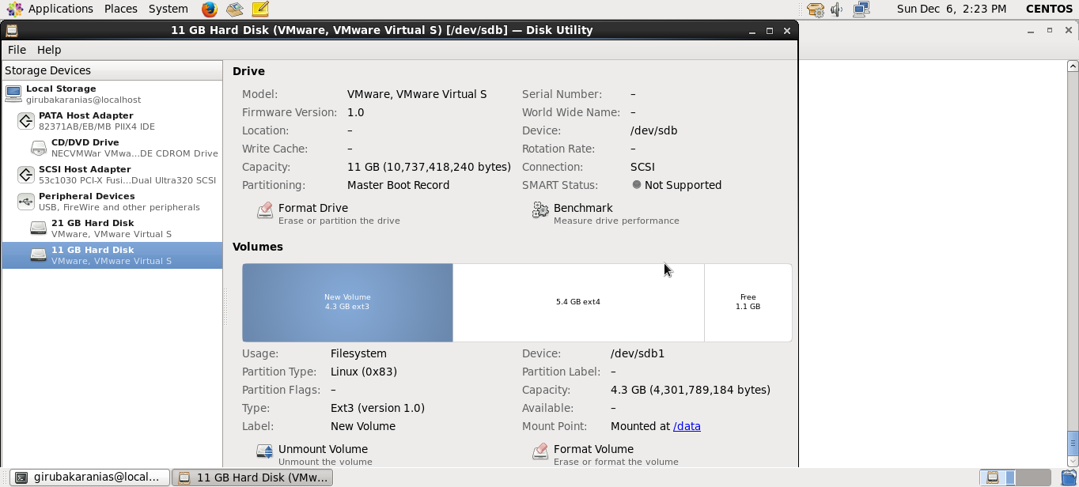

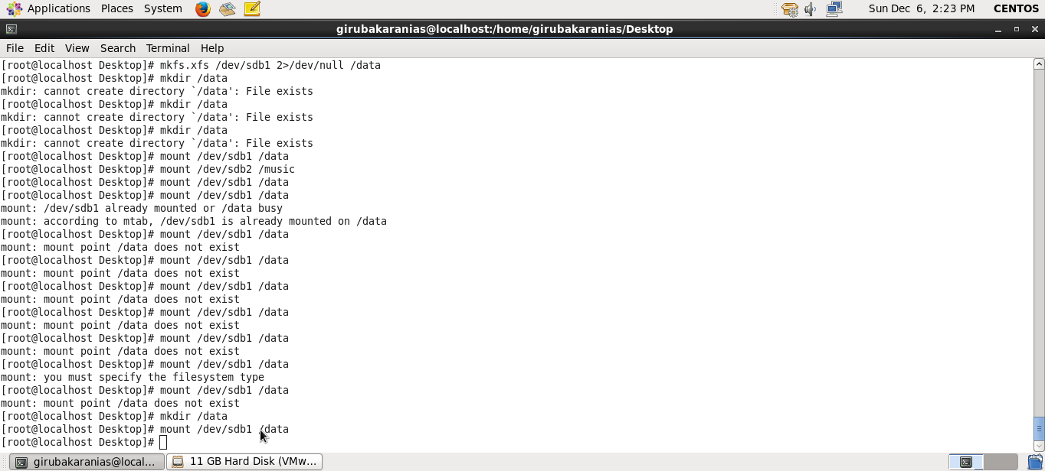

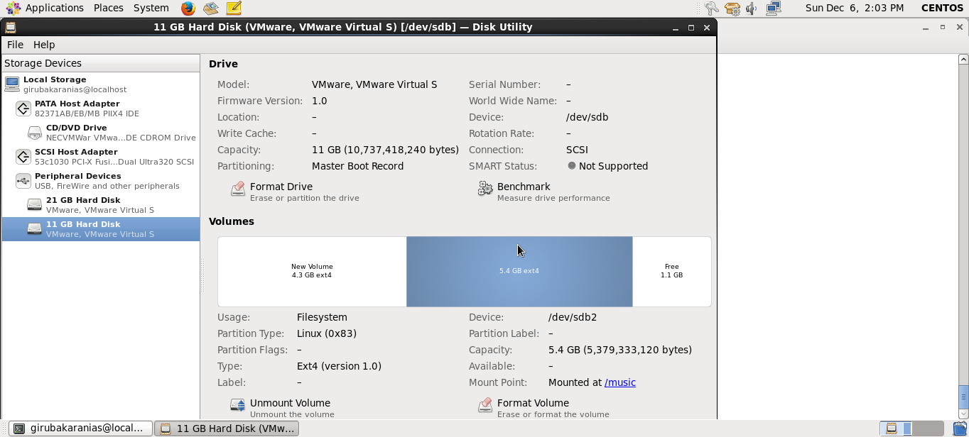

1. **Create one file of 1GB in each of the mount point created above.**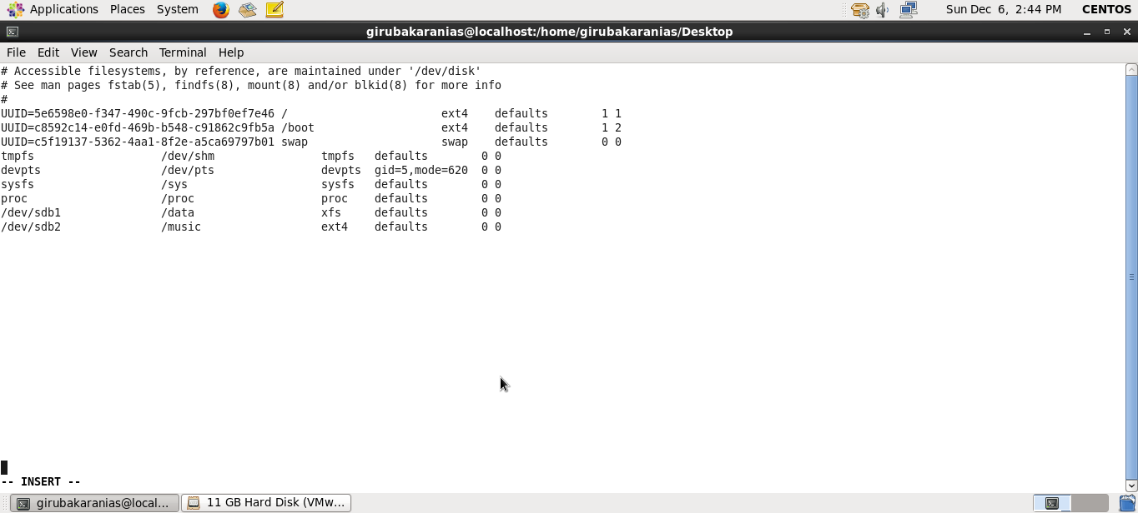
2. **Verify the disk Consumption and disk space free in the mounted partitions**

